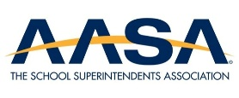
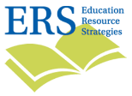
Leveraging the New Scholarship Tax Credit:
Deciding What Will Work For You
Session Guide and Note Catcher – September 2, 2026
Guiding Question:
How can district leaders address “pinch points” to
increase the likelihood of success and impact through FSTC?
- How could we generate donations at scale?  - How could we most easily register eligible students for services? | - What role will we play in matching students to scholarship-funded services?  - Which SGOs will we affiliate with and how will we partner?

Strategic options: From open market to “closed loop”
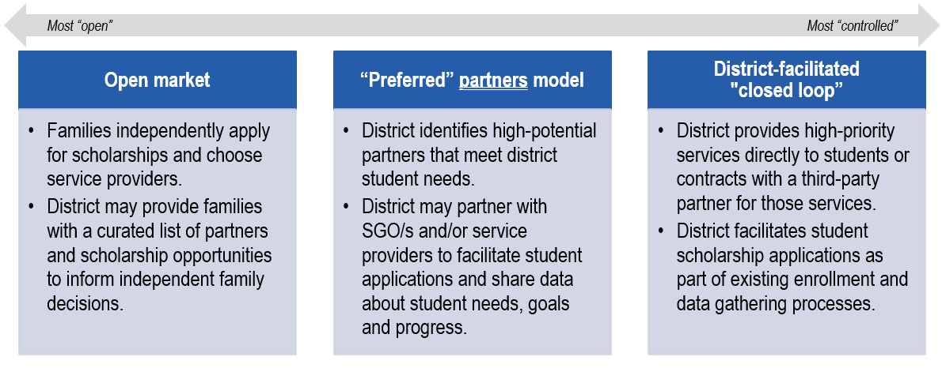
What about these models are most and least appealing for your community?
For reference

How the tax credit process is likely to work (simple view)
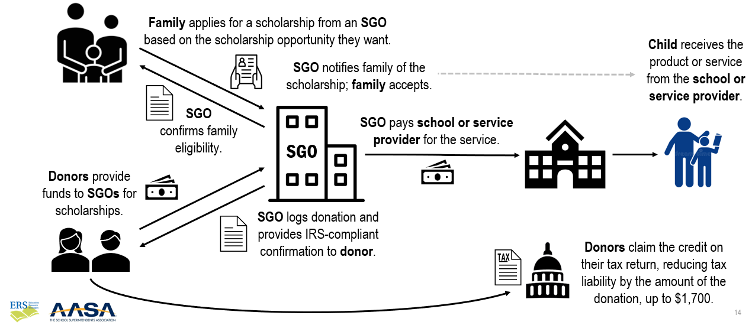

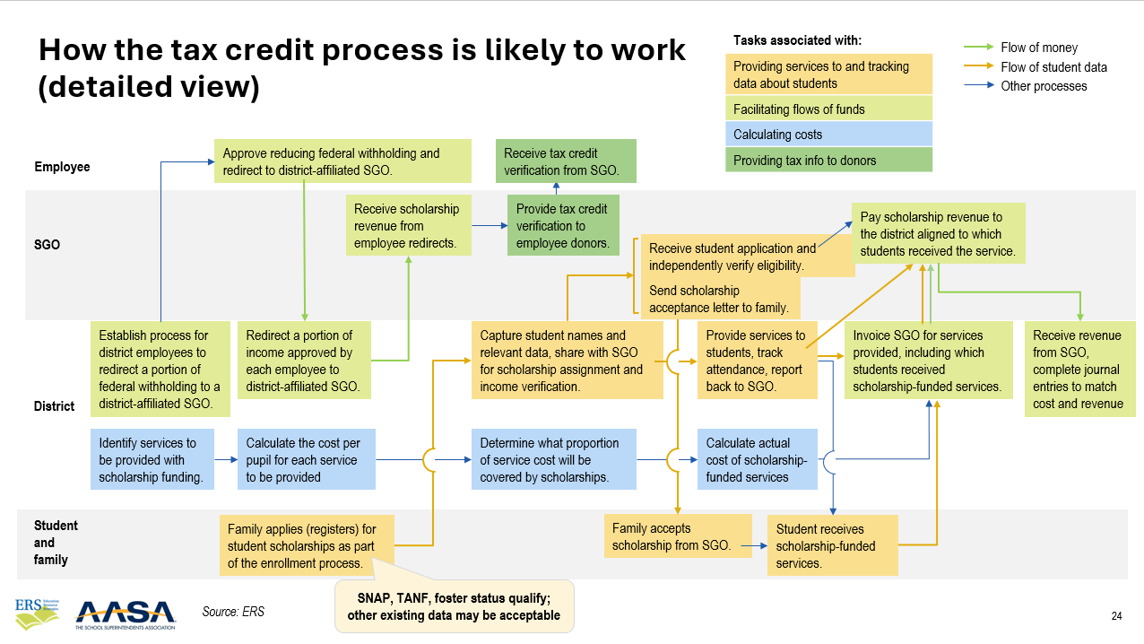

Pinch points | Your questions and reflections
How could we generate donations at scale?
How could we most easily register eligible students for services?
What role will we play in matching students to scholarship-funded services?
Which SGOs will we affiliate with and how will we partner?

Questions and reflections from discussion with Dr. Jeffcoat
Your questions | Your reflections

Final webinar in the series  September 22, 3-4 p.m. ET:  Designing and implementing an operating model that works for us | Register here  

