FSA ID How-to guide
Creating an FSA ID is the first step in completing the FAFSA

What is an FSA ID?

Go to studentaid.gov and click "create account" in the upper right hand corner. The application is available in English and Spanish.
The Federal Student Aid (FSA) ID is a username and password that is required to log in and access all Federal Student Aid websites, including the FAFSA. The FSA ID also serves as a legal signature when you submit your FAFSA.

Who should create an FSA ID?
You and one or both of your parents must create an FSA ID before completing the FAFSA. If you are an independent student, you will not need to have your parent or legal guardian create an FSA ID. If you have a sibling who attended college before you, your parent may already have an FSA ID.
Every person contributing information to a FAFSA will need an FSA ID - including parents who do not have a Social Security Number

If you are a student without a Social Security Number, you will not be able to create an FSA ID or complete the FAFSA. Check with your state and college(s) to determine what financial aid you may be eligible for.

What information do I need to create an FSA ID?
- Full name and social security number, as they appear on social security card (if applicable)

Save your FSA ID username and password somewhere safe.
- Date of birth
- Valid email address & phone number
- Immediate access to your email account
- Your residential address

FSA ID How-to Guide: Application Process
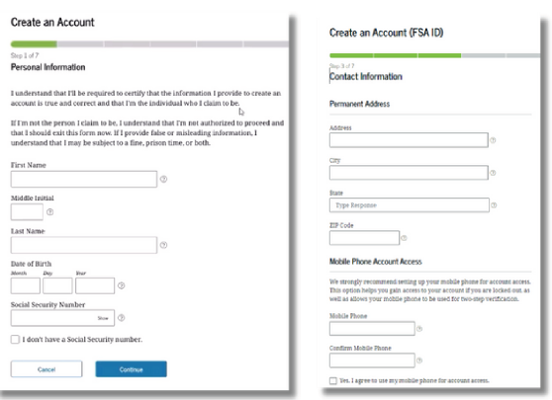
- Add name, date of birth, and Social Security Number exactly as it appears on official documentation.
- Check the box if you don't have a Social Security Number and see the next page for more information
- Create a password that you don't use for other accounts
- Provide your mobile phone number for more ways to access your account

How do I make the challenge questions?
You will need to select four challenge questions from a dropdown list and provide answers. If you forget your username or password, you may need to answer the challenge questions to access your account.

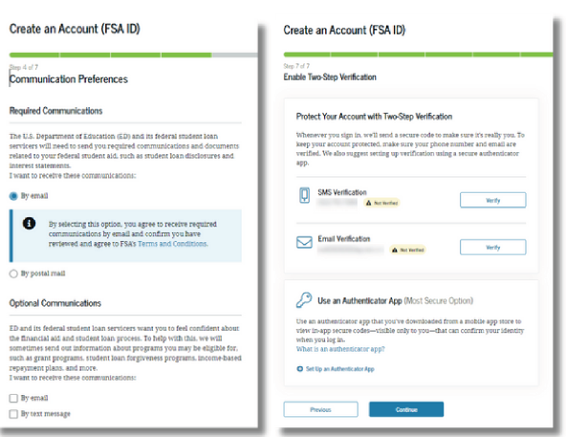
- Select how you would like the Department of Education (the people who manage the FAFSA) to communicate with you, and in what language (English or Spanish)
- We recommend email to get communications quickly
- Set up two-step verification
for your FSA ID with your
phone number, email, and/or authenticator app
- We recommend setting up all methods so you have multiple options to log in

FSA ID How-to Guide: Additional Steps for Contributors withoutd Social Security Numbers (SSN)

Remember that you should only create an FSA ID without an SSN if you are either:
- A parent or spouse of a student completing the FAFSA
- A citizen of the Freely Associated States (the Republic of the Marshall Islands, the Federated States of Micronesia, and the Republic of Palau) and need to complete the FAFSA

What is identity verification?
If you do not have an SSN you need to confirm your identity through a series of questions at the end of the account creation process. The personal information from these questions comes from the TransUnion Credit Bureau, but this is not a credit check.

You will have one chance to answer the questions correctly, or you will need to confirm your identity through an alternative process.

How do I know the results of the identity verification?

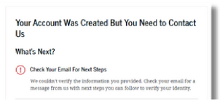
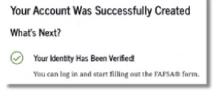

- This screen will appear if your identity was successfully verified. You do not need to take any additional steps before starting the FAFSA.

- This screen will appear if your identity was not able to be verified
- You should receive an email with a case number and instructions on how to manually verify your identity. If you don't receive an email, contact FSA at 1-800-433- 3243 to ask for your case number and start the process.
- You will need to complete the Attestation Form and provide documentation that proves your identity

Is the personal information I provide protected?
According to the National College Attainment Network, "federal law prohibits the use of data collected through the FAFSA for anything other than calculating federal and state financial aid. Entities with access to this data are also required to protect the data against security threats or unauthorized uses. FSA [the Office of Federal Student Aid] will not share FAFSA information with anyone except the schools the student indicates they want to attend...and a few federal and state government agencies (so they can check to be sure the information is accurate or determine financial aid eligibility)." See more here:
http://www.ncan.org/resource/resmgr/policyadvocacy/top_10_mixed_status_families.pdf

FSA ID How-to Guide: Using and Troubleshooting your Account

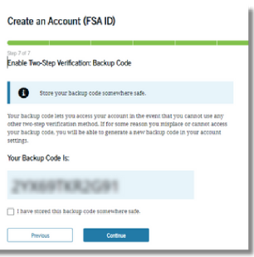
  - Enable the secure backup code, which will help you access your account if the other verification methods won't work

Now that you created your FSAID, your information must be verified and matched with the Social Security Administration (if you provided a social security number).
  - Make note of your backup code and store it somewhere safe

When can I use my FSA ID?
If you provided an SSN, your FSA ID won't be fully functional until you receive an email in a few days about your SSA match. Likewise, if you do not have an SSN and need to go through the manual identity verification process, your FSA ID won't be fully functional until 1-3 days after submitting your documents. You can still use your FSA ID immediately to access your studentaid.gov account dashboard, and start or contribute your information to a FAFSA. However, uAspire recommends waiting to do this until your FSA ID is verified. If you do not have an SSN and your identity was successfully verified, you can use your FSA ID immediately to complete the FAFSA.

Can I edit my FSA ID?
Yes. If your personal information changes or you would like to update anything on your account, you can make changes by logging in at studentaid.gov and selecting "settings" under your account information.

What if I forget my FSA ID username or password?
You can retrieve your username or reset your password by having a secure code sent to your phone/email. You may also answer your challenge questions, but this option comes with a 30-minute waiting period before you can use your account again.

What do I do if I need help?
Contact the FSA ID Help- Center at via email, chat or by calling 1(800) 433-3243.

