

CANDIDATE FILING PACKET: 2024 Election

Format for Candidate Information

President-Elect

AASA’s website will serve as the official election communication vehicle. Candidates’ answers to provocative issues-related questions will appear on the AASA website. All candidate profiles will be published, along with a head-and-shoulder photo. Please submit a color photograph (JPG). Select your photograph carefully, looking for clarity, sharpness and technical quality.

All AASA president-elect candidates must submit the following items as part of the filing documentation. Responses are to be submitted as a Word document via e-mail (a sample format is included in this packet). Please do not submit election materials in a PDF format.

Deadline: Submit the following information no later than 5:00 p.m., Friday, December 1, 2023 EST.

- Mini-resume describing qualifications and demographic information:
  - Name
  - Number of years as an AASA Member; number of years as a chartered affiliate member; and the term(s) of service on the AASA Executive Committee and/or the AASA Governing Board
  - Current position, including title, school district or other organization, city, and state with starting date
  - Most recent previous position, including title, school district or other organization, city, and state with starting and ending dates
  - Post-secondary education (Bachelor’s, Master’s, Advanced Certificate, Doctorate). Please include names of institutions, city, and state, and the year(s) in which degree(s) was received. Please provide this in reverse order with the most recent degree listed first.
  - AASA activities and other activities. Please provide this in reverse order with the most recent activities listed first. (Limit to 10 items total. May include volunteer leadership, affiliations, conference presentations)

2. Respond to the following two questions:
a. Why are you seeking election to the office of AASA president-elect? (100 words or fewer)
b. If elected, what will be your #1 priority? (50 words or fewer)

- Each candidate will write and submit a 600 – 650 word essay on a topic of their own choosing as if it were to be used as a monthly “AASA President’s Column” found in The School Administrator.

- Candidates are to submit a color photograph in a JPG format, to be included with materials distributed to AASA Governing Board members. Candidates should select photographs carefully, looking for clarity, sharpness and technical quality. Nominated AASA president-elect candidates will have their pictures printed on the biographical materials included with the ballots and on the AASA website.
- $500 filing fee submitted by check to AASA OR by credit card payment by phone at (703) 528-0700.

The above questions and all others to be asked of candidates will appear on AASA’s website along with all the other candidates’ responses. It is advisable not to repeat the questions in your answers, to facilitate staying within the word limits as noted.
AASA President-elect
Candidate Filing Packet

Checklist of all items required to be received by 5:00 p.m. EST on December 1, 2023:

___ Candidate has notified AASA in writing of his/her intention to seek the office of president-elect. A statement of intent is enclosed.

___ Candidate has notified their state association executive director through a written statement of intent. A copy is enclosed.

___ Responses to items 1 through 4 above.
___ Item #1 – Mini-resume
___ Item #2 - Answers to two questions
___ Item #3 - Essay (600-650 words)
___ Item #4 - Color Photograph

___ Candidate pledge enclosed.

___ $500 filing fee enclosed.

Please submit photographs, written responses, and additional materials listed above to (it is preferred that they be submitted via email):

Kat Sturdevant
Advocacy and Governance Coordinator
AASA
1615 Duke Street
Alexandria, VA 22314

ksturdevant@aasa.org
571-480-0172 (Cell)

AASA President-elect
Candidate Filing Packet

AASA Election: President-elect Candidate Pledge

I have read the rules and procedures contained within the AASA Election Guidelines and I agree to obey the AASA election rules, in spirit and in word.

__________________________________________________ ________________
Signature Date

Address ____________________________________________________________________________________

____________________________________________________________________________________

____________________________________________________________________________________

Office Telephone: (____)___________________________________

FAX Number: (____)___________________________________

Email Address: ____________________________________________________________________________________

The AASA Election Guidelines are posted on the AASA website at www.aasa.org

AASA President-Elect
Candidate Filing Packet

Sample Letter

(For use by Candidates for president-elect)

Date

Dear Colleague:

I am seeking nomination to become a candidate for the position of president-elect of AASA, The School Superintendents Association.

Compliance with the AASA electoral process requires that I ask your organization not to endorse or promote my candidacy or urge my election.

This does not preclude your organization from noting that AASA has an election and noting all of the candidates, including me. AASA’s electoral process was reformed because, like the national political electoral process, it had become too expensive and prolonged. The Executive Committee of AASA adopted the new rules regarding endorsements of candidates to make the campaigns more consistent with standards of conduct and ethics of school administrators, by having all campaigning done through AASA publications and at the AASA National Conference on Education.

Individual active members may communicate with other AASA active members, about a single candidate and support of that candidate by letter, fax or electronic transmission. Any cost of the mailings, faxes, or electronic transmissions must be the responsibility of the individual and cannot be that of the candidate or other third party. No enclosure, attachment or brochure may be distributed with the letter, fax or electronic transmission.

A member may discuss a candidate on a personal, one-to-one individual basis with another member. Endorsement of candidates by a state association, caucus, committee, group or corporation could result in sanctions against me, including a 10 percent deduction from my vote total.

Please call me if you have any questions about AASA election rules or the information you plan to publish. Thank you for your consideration of this matter.

Sincerely,

Appendix: E

CAN DO LIST

- IDENTIFICATION AS A CANDIDATE.

The minute the proper notification is given to the state and to AASA, a candidate may identify himself or herself as a candidate seeking nomination for AASA president-elect. The candidate may respond to questions, engage in discussions but may not solicit votes or support

- PROFESSIONAL MEETINGS, CONFERENCES OR SEMINARS.

At any time before or during the election process, a candidate may attend all such meetings. Only after proper notification may the candidate identify himself or herself as a candidate. Although discussion may occur about the candidacy, no campaigning is allowed. A candidate shall not be introduced as such if the introduction could be interpreted as an endorsement or support unless all candidates are introduced at the same meeting and in the same manner.

A candidate for AASA president-elect may be recognized at a statewide or intra-state regional meeting in the resident state of the candidate and the association, without extending the same privilege to other candidates for the same position.

A state association may invite or allow a candidate for AASA office from within the state, to address a statewide or intra-state regional meeting within the state without extending the same privilege to other candidates for the same position so long as the address is not a campaign speech, there is no mention of his or her candidacy, nor is there a request for support.

- NATIONAL CONFERENCE ON EDUCATION ACTIVITIES.

(Refer to the separate section about this within these Guidelines, page 10.) A candidate may engage members personally throughout the National Conference on Education. This is the only time campaigning is allowed.

- APPEARANCES AT THE NATIONAL CONFERENCE ON EDUCATION.

Specific appearances, including introduction at the Opening General Session and the Candidate’s Forum are described previously. Candidates may choose to attend any breakfast or reception and they will be provided with a list of scheduled breakfasts and receptions. Candidates shall not interrupt a program or presentation in progress.

A candidate may continue their official AASA related responsibilities as specified in 2. C. AASA Related Activities (page 4) and confirmed by the Executive Officers. Participation in the “Singing Superintendents” is permissible.

- AASA RELATED ACTIVITIES.

An AASA Active Member serving in an official AASA related position may continue to perform the duties and responsibilities associated with that position, even after declaring his or her candidacy for AASA president-elect.

- Filing Fee.

All or part of the $500 candidate’s filing fee may be paid by the candidates’ home state association, as long as it is received by the filing deadline. The filing fee may be sent by check to AASA headquarters (1615 Duke Street, Alexandria, VA 22314) OR by electronic payment by phone at (703) 528-0700.

- Distributions/Mailings.

Mass campaign mailings, distributions, and/or communications made to eligible voters for candidates including electronic media such as, e-mails, faxes, telephone or other electronic communications shall be permitted so long as the mailings are not initiated by a candidate running for office and are conducted by someone who knows the candidate personally (adhering to the “reasonable person standard” – what a reasonable person would do under the same or similar circumstances).

Any member, including: state association executive directors, past presidents of AASA, current Executive Committee members (except for the three AASA officers) and current Governing Board members may discuss a candidate on a personal, one-to-one individual basis with another member. A member may, on an individual basis, answer a personal question about a candidate, including ‘Who are you going to vote for?’ without being in violation of the AASA Election Guidelines.

However, when speaking before a public group(s), endorsement of a candidate by a state association executive director, past president of AASSA, current Executive Committee member or current Governing Board member is prohibited.

Individual active members, including state association executive directors, past presidents of AASA, current Executive Committee members (except for the three AASA officers) and current Governing Board members, may communicate with other AASA active members (on an individual, one-to-one basis), about a single candidate and support of that candidate by letter, fax or electronic transmission. Any cost of the mailings, faxes, or electronic transmissions must be the responsibility of the individual and cannot be that of the candidate or other third party. No enclosure, attachment or brochure may be distributed with the letter, fax or electronic transmission.

AASA employees and current association officers cannot participate in the election process.

- ENDORSEMENTS

There shall be no public endorsement(s) made of an AASA candidate by a state association or state association executive director, past president of AASA, current Executive Committee member, current Governing Board member, caucus, committee, group or corporation.

CANNOT DO LIST

- NATIONAL CONFERENCE ON EDUCATION ACTIVITIES.

At the AASA National Conference on Education, a candidate for AASA president-elect may not preside over a session or be a program presenter, moderator, or facilitator.

- ENDORSEMENTS

AASA candidates for office may not be publicly endorsed by any state association or state association executive director, past president of AASA, current Executive Committee member, current Governing Board member, caucus, committee, group or corporation.

- CAMPAIGN CONSULTANTS

Candidates are prohibited from using paid campaign consultants.

- AASA MEMBERSHIP LIST

No candidate or their supporters may use any part of the AASA membership list in any way for campaign purposes.

- Candidate Campaigning

Other than National Conference on Education activities, a candidate for AASA president-elect may not:

- Travel to states with the express purpose of promoting his/her candidacy.
- Establish an advisory committee or group to in any way assist with the campaign.
- Spend any funds from any source to promote their candidacy. This includes distributing such things as: flyers, campaign brochures, newsletters, pins, pens, pencils, buttons, compact discs, trinkets or any other tangible items such as receptions, complimentary drinks or dinner, etc. If in doubt a candidate should contact either the election coordinator or the chair of the Election Committee.

- Be publicly endorsed by:
- State associations or state association executive directors
- Past Presidents of AASA
- Current Executive Committee members
- Current Governing Board members
- A caucus, committee, group or corporation

MODEL LAYOUT FOR RESUME (please follow this model)

AASA, The School Superintendents Association
President-Elect Candidate 2013
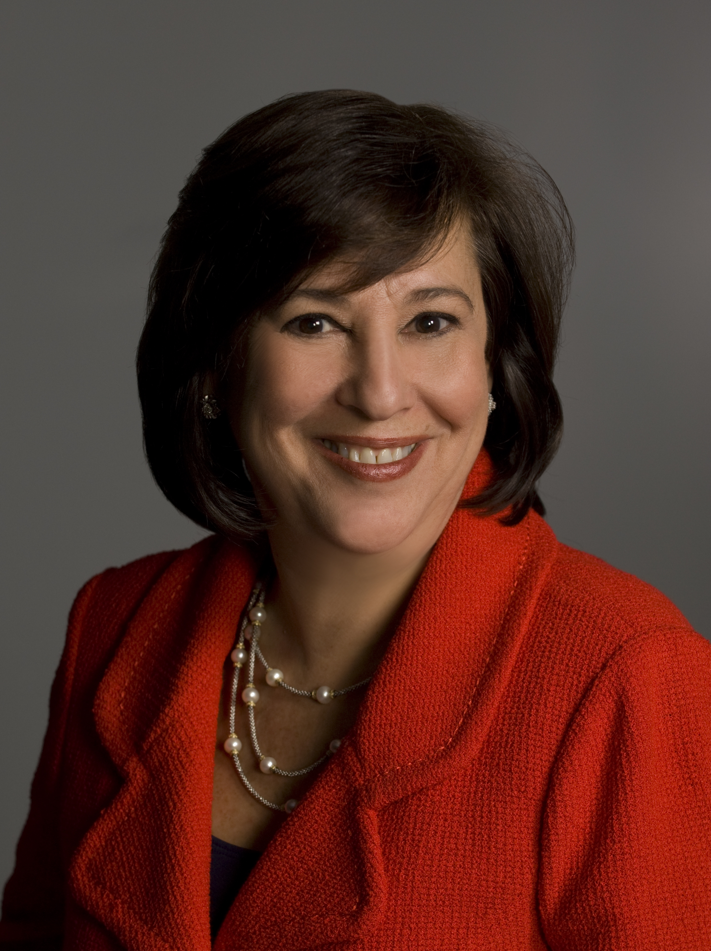

Amy F. Sichel, Ph.D.
Superintendent
Abington School District
Abington, Pennsylvania

Member:
- AASA, 2001-present
- AASA Governing Board, 2006-present
- Pennsylvania Association of School Administrators, 2001-present

Current Position: Superintendent
Abington School District
Abington, Pa.
2001-present

Previous Position: Assistant Superintendent
Abington School District
Abington, Pa.
1993-2001

Post Secondary Education:
- Certification in Elementary & Secondary Principalship/Letter of Eligibility for Superintendency, University of Pennsylvania, Philadelphia, Pa., 1986
- Ph.D., University of Pennsylvania, Philadelphia, Pa., 1981
- M.S., University of Pennsylvania, Philadelphia, Pa., 1976
- B.A., Lafayette College, Easton, Pa., 1975

AASA and Other Activities:
- Testified on ESEA, AASA representative, U.S. House Committee on Education and the Workforce, 2011
- Pennsylvania Superintendent of the Year, 2010; Pennsylvania Superintendent of the Year Panel Presentation, 2010 and 2011; AASA Superintendent of the Year Forum, 2010
- AASA/American Federation of Teachers, panelist on Teacher Discipline, 2011
- PASA/PSBA Conference presenter, “Opportunities to Learn: Equity, Access and Success for All,” 2009, 2010 and 2011; “A Healthy Student Is Ready and Able to Learn,” 2009
- Pennsylvania Association of School Administrators: president, 2010-11; Board of Governors, 2008-present; Professional Development Committee, 2004-present, chair, 2007-09
- International Educators Excursion Participant: America-Israeli Friendship League, 2010
- China Bridge Delegation: China Hanban Institute and College Board, 2009
- University Teaching in Education: University of Pennsylvania Graduate School of Education, Adjunct Associate Professor, 1981-present; Delaware Valley College, Adjunct Instructor, 2011
- Pennsylvania State University, Abington College, Executive Advisory Board member, 2002-present
- Suburban Superintendents Study Council 2001-present, president, 2004-09

Why are you seeking election as AASA’s president-elect?

Answer … Answer … Answer

If nominated and elected, what will be your No. 1 priority?

Answer … Answer … Answer

